Aim: To demonstrate the presence of water and carbon dioxide in the products of hydrocarbon combustion.
Demonstration Guide: Products of Combustion

Equipment | Method | Notes and guidance
- Large glass funnel  - 2x boiling tubes  - 2x two-holed rubber bungs  - Glass/plastic tubing for connections (see diagram)  - Filtration pump  - Retort stands and clamps  - Lighter  Chemicals:  - Small candle (tea light)  - Blue cobalt chloride paper  - Calcium hydroxide (limewater) | - Assemble the apparatus as per the diagram, with a piece of blue cobalt chloride paper in the first boiling tube and 20 ml of limewater in the second.  - Turn on the pump to draw air through the apparatus.  - Light the candle and observe the changes to the cobalt chloride paper and limewater. | Ensure you have read all safety notes before attempting this practical. If you have never done this practical before, arrange to do a trial run with the technician before the lesson.  Discuss the setup with the technician. Your department may have different equipment to that listed here.  Cobalt chloride paper turns from blue to pink in the presence of water. Limewater turns from clear to cloudy (milky) in the presence of carbon dioxide. These two reactions can be demonstrated before the combustion demonstration.  Air itself contains carbon dioxide and water vapour. This experiment can be repeated without a tea light to demonstrate that although the changes to cobalt chloride paper and limewater will still eventually be observed, it takes a lot longer.  Smoke contains a lot more carbon dioxide than air. This can inspire discussion of pollution and the greenhouse effect.  A risk assessment must be completed for this practical. The risk assessment must be specific to the class involved and written only by the teaching member of staff.
Setup Diagram
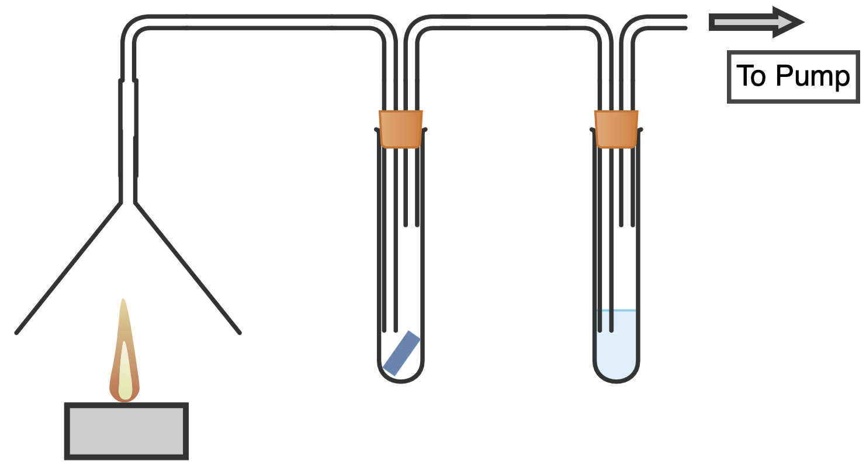

Clearing up
Discuss clearing away with your technician colleague beforehand. Ensure students do not take anything from the lab, especially toxic cobalt chloride paper and the lighter.
Technician notes
Discuss this practical with the teacher beforehand. Your equipment setup may vary from the provided diagram.

Old cobalt chloride paper that has begun to lose its blue colour can be revived with a drying oven/desiccation chamber.

Many different types of filtration pump can be used, but it is important to not create such a strong air flow that the candle blows out. A basic pump that fits to a lab tap will be more than sufficient.

